TUTORIAL: GIT AND GITHUB 6. GUI - 2018

Install GitHub

This is the continuation from the previous tutorial: [GIT and GitHub - 5. Uploading to GitHub](http://www.bogotobogo.com/cplusplus/Git/GitHub_Uploading.php).

In this section, we'll use GUI version of Git.

Let's go to <http://git-scm.com/>

Download and install "Windows GUIs":

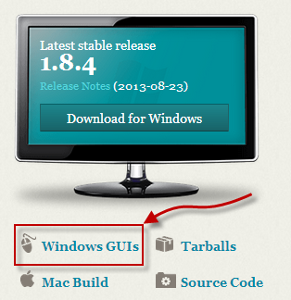

Select GitHub for Windows:

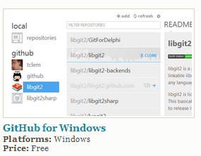

Then, download it.



Install it.

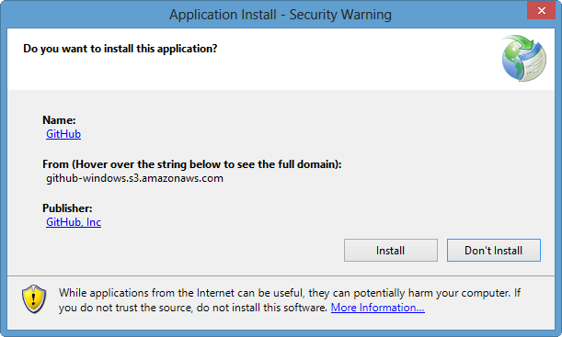

Setting up GitHub

We need to login:

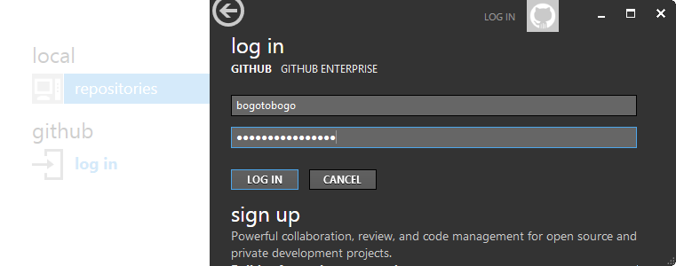

The first window after logging in does not have any information about our local repository. So, we should set it up using Tools > Options...

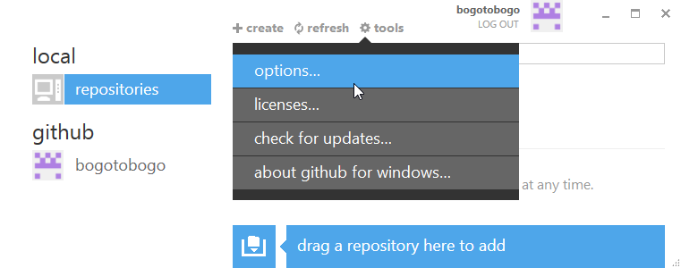

Type in the project directory into the "default storage directory":

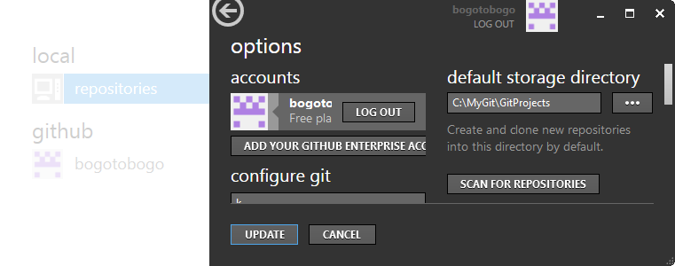

Click "SCAN FOR REPOSITORIES", then, we'll have this:

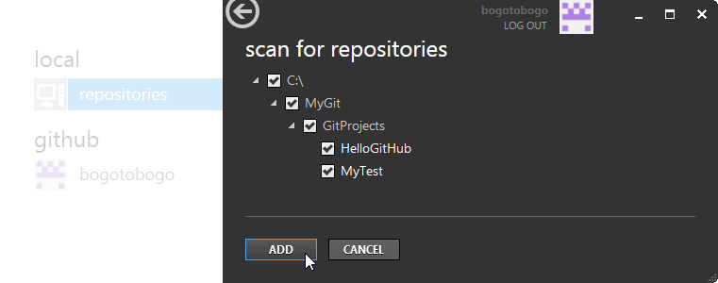

Add > Update:

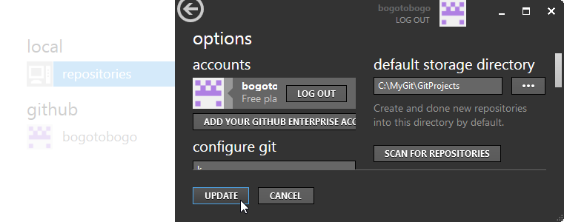

Now we see the local repositories as well:

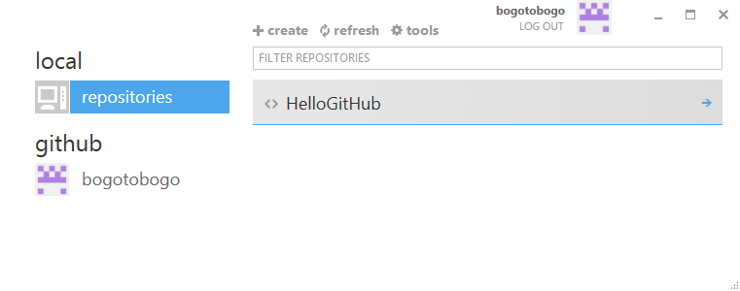

Creating a New Repository

For testing purpose, I made a new project called "HelloGit2" which is almost the same as "HelloGit".

Select "create" on GitHub client:

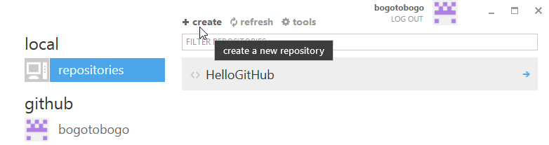

Type in the exact name for the new project, then Hit "CREATE"

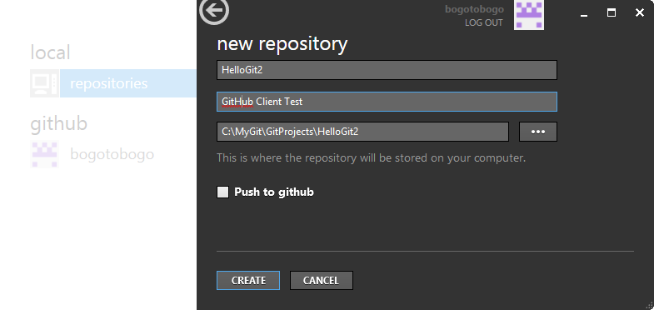

Now we see a new repository called "HelloGit2" has been created.

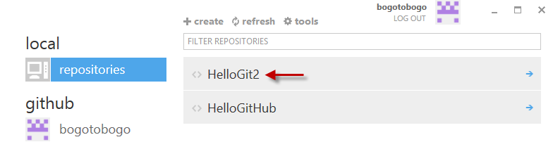

Committing and Pushing to GitHub

Since we made a new repository, we want to commit our project to a local repository:

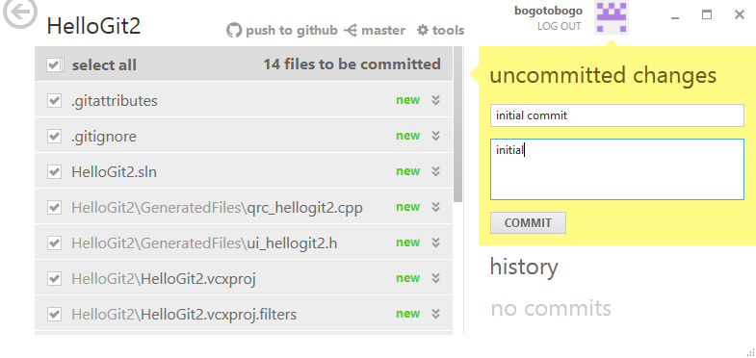

Unfortunately, in Gui mode, we do not see the **stage** activity, since it's done in background. Now, we may want to do "push to github":

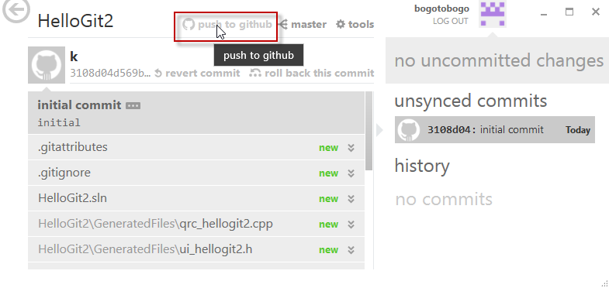  
  
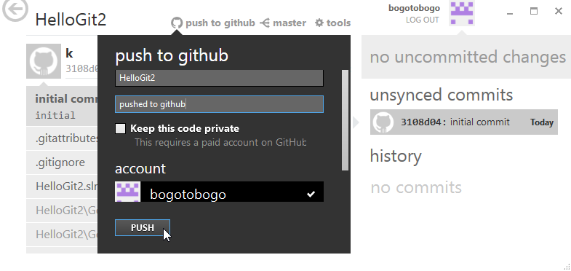  
  
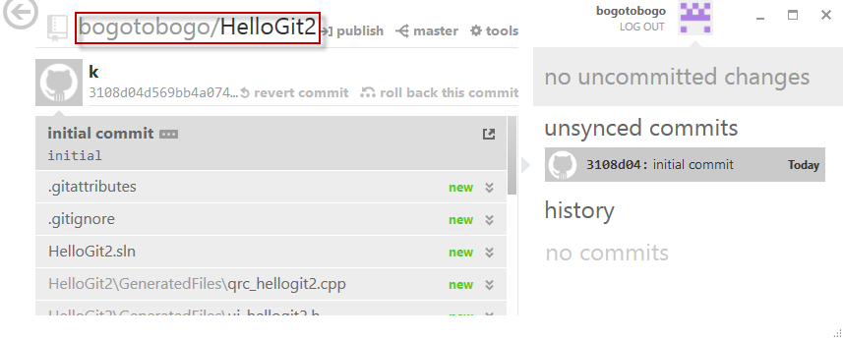

Also, we need to publish as well:

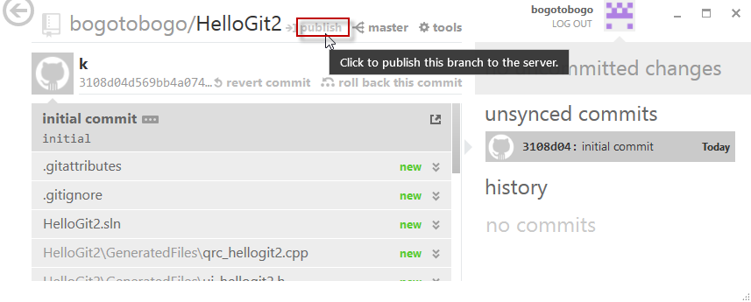  
  
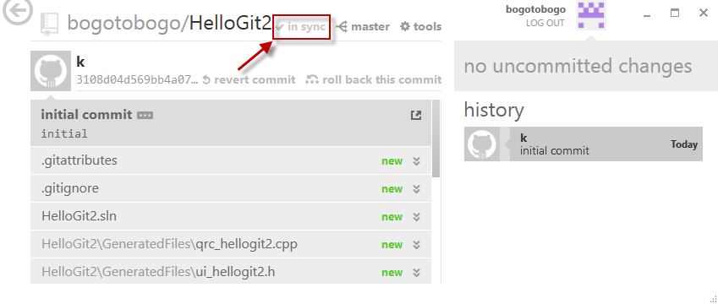

Looks like it's been pushed/published to GitHub successfully (Note that the marked **in sync**). Now we need to check if it really worked. Let's go to GitHub, <https://github.com/bogotobogo>.

Indeed, it worked!

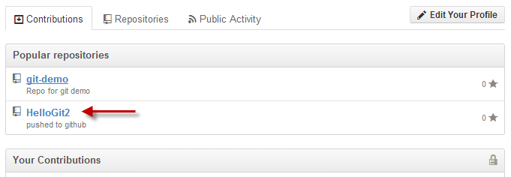  
  
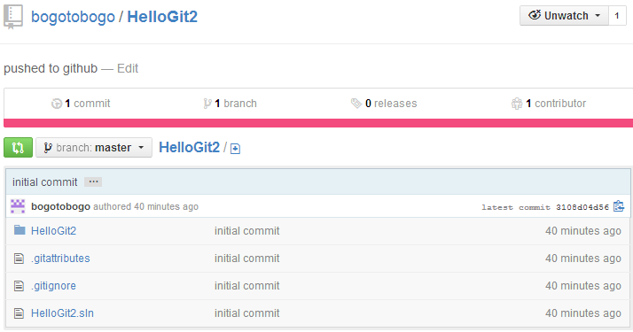

Updating the Source

Now, as a last step, we need to check if updating is working.

I'll just modify ReadMe.txt:

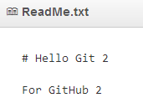

We already see the changes in my local disk:

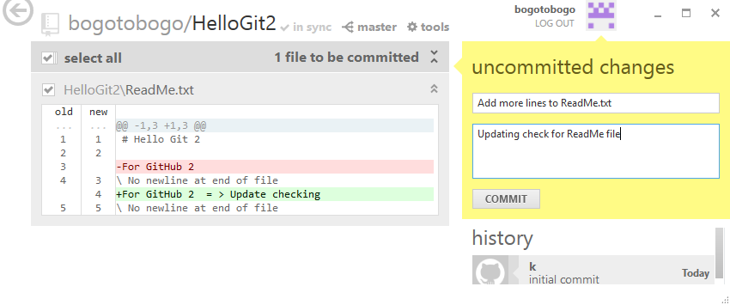

After the commit, what we need to do is to **sync**:

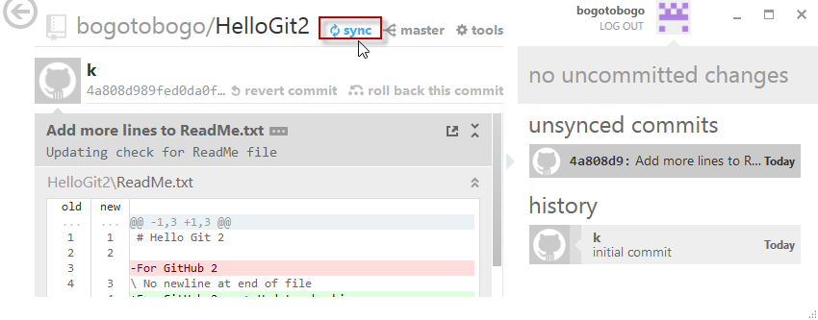

Once the sync is done, go to GitHub and check the updates:

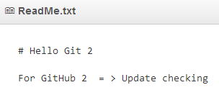

Yes, update is successful!